Exp. No: 2
Electric Field and Electric Flux Density in a Sphere Full of Charges with Varying Radius
Test case (i) Determination and plotting of electric field and electric flux density in sphere full of charges with varying radius
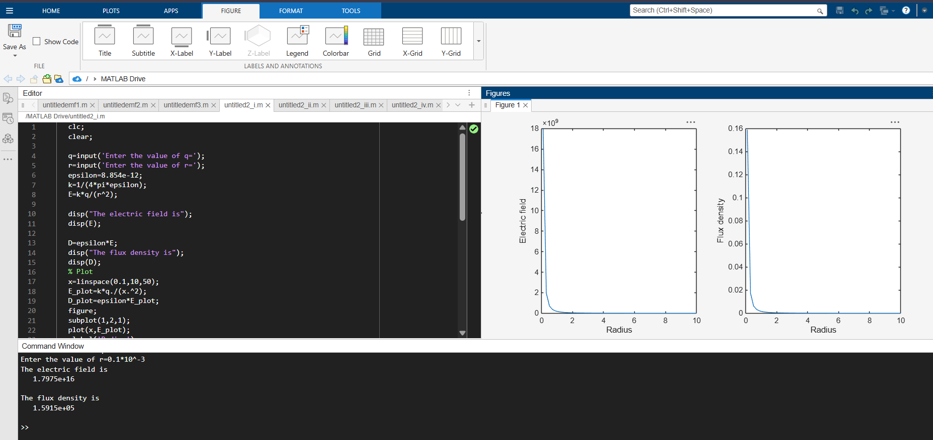
Test case (ii) Derive and plot the electric field (E) and electric flux density (D) inside a uniformly charged sphere with charge density ρ₀
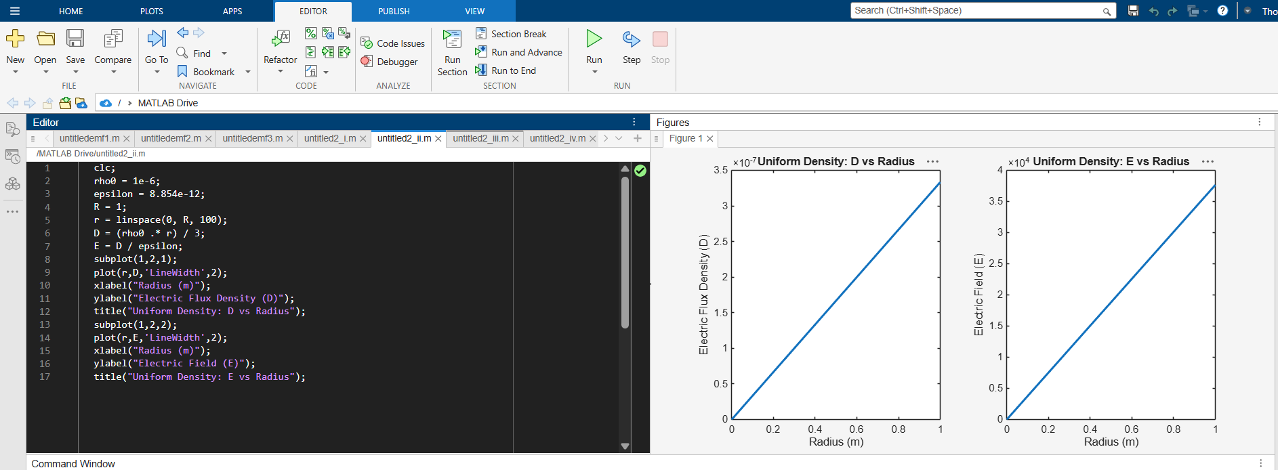

Test case (iii) For a sphere with a linearly increasing charge density ρᵥ = ρ₀r, derive and plot the electric field (E) and electric flux density (D)
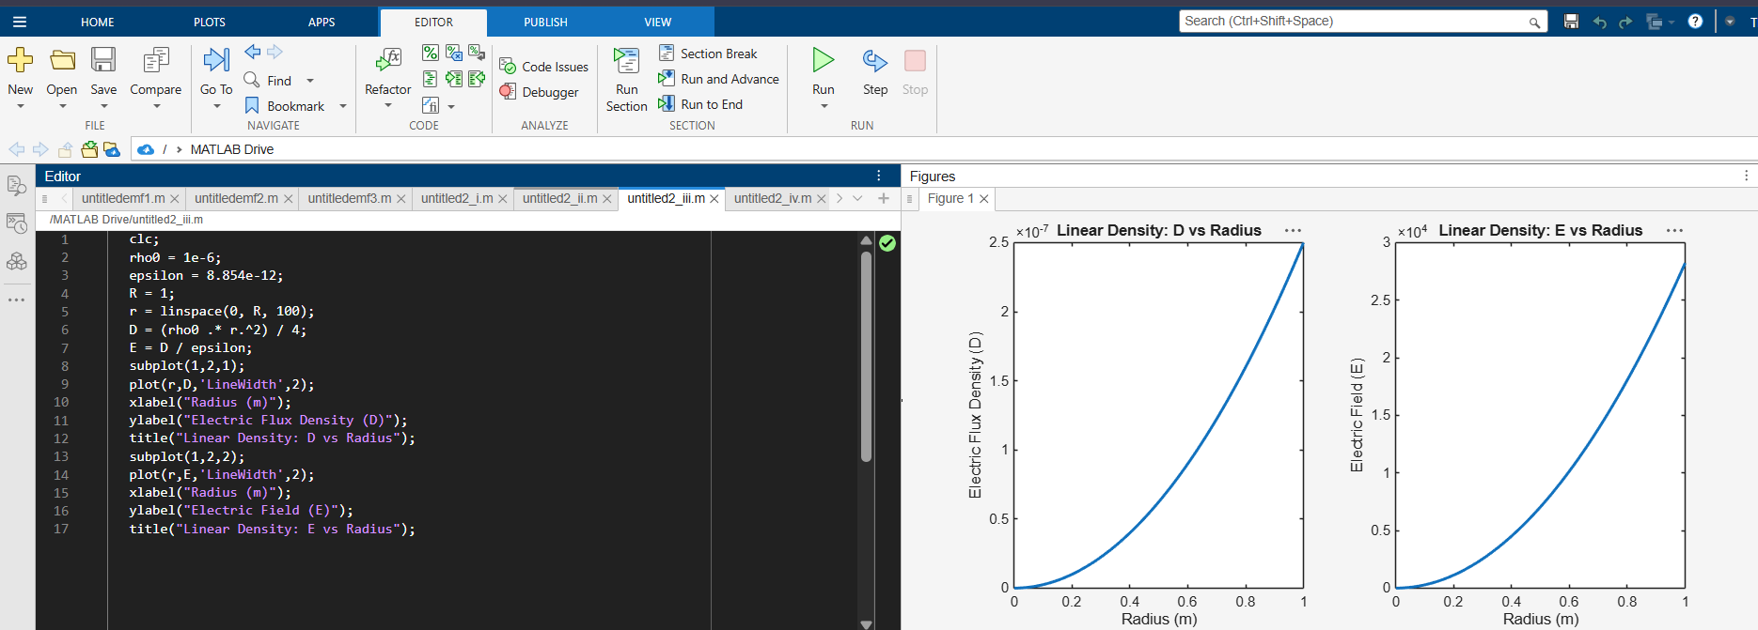
Test case (iv) A sphere of radius R = 2 m has a uniform charge density ρ = 3×10⁻⁶ C/m³. Calculate and plot electric field inside and outside the sphere
